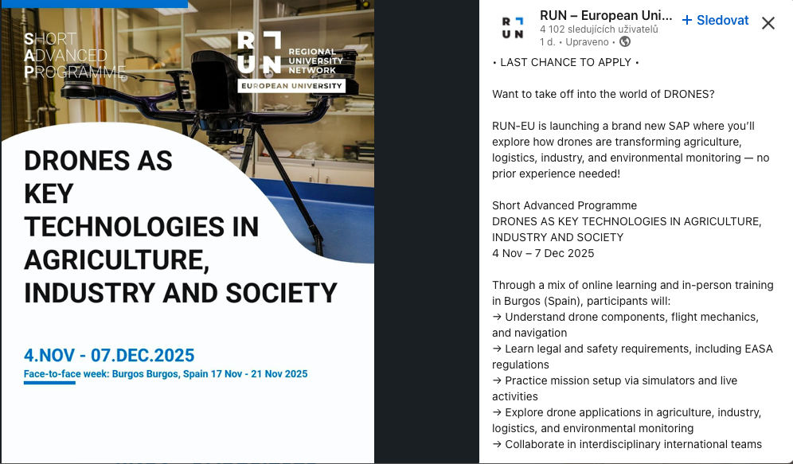

**LINK:** <https://run.eu/products/sap-dronagis-02>

LAST CHANCE TO APPLY •

Want to take off into the world of DRONES?

RUN-EU is launching a brand new SAP where you’ll explore how drones are transforming agriculture, logistics, industry, and environmental monitoring — no prior experience needed!

Short Advanced Programme

DRONES AS KEY TECHNOLOGIES IN AGRICULTURE, INDUSTRY AND SOCIETY

4 Nov – 7 Dec 2025

Through a mix of online learning and in-person training in Burgos (Spain), participants will:

→ Understand drone components, flight mechanics, and navigation

→ Learn legal and safety requirements, including EASA regulations

→ Practice mission setup via simulators and live activities

→ Explore drone applications in agriculture, industry, logistics, and environmental monitoring

→ Collaborate in interdisciplinary international teams

🎓 Academic Recognition: 4 ECTS

🧑 Open to all RUN-EU undergraduate and postgraduate students – no prior technical experience required

🗓 In-person week: 17–21 Nov 2025 at the [Universidad de Burgos](https://www.linkedin.com/company/universidad-de-burgos/), Spain

🛩️ Max. 25 participants • Selection based on motivation & interdisciplinary interest

🏁 APPLY BY 3 OCTOBER

This SAP is co-organised by the [Technological University of the Shannon](https://www.linkedin.com/company/tus-ie/), the [Universidad de Burgos](https://www.linkedin.com/company/universidad-de-burgos/) and the Fundación UBU.

+INFO: [bit.ly/SAP_Drones_Key](http://bit.ly/SAP_Drones_Key)

[Technological University of the Shannon](https://www.linkedin.com/company/tus-ie/)

[Polytechnic of Leiria](https://www.linkedin.com/company/politecnicodeleiria/)

[Instituto Politécnico do Cávado e do Ave](https://www.linkedin.com/company/politecnico-do-cavado-e-do-ave/)

[Häme University of Applied Sciences, HAMK](https://www.linkedin.com/company/hamk/)

[NHL Stenden](https://www.linkedin.com/company/nhlstenden/)

[FHV - Vorarlberg University of Applied Sciences](https://www.linkedin.com/company/fachhochschule-vorarlberg/)

[Universidad de Burgos](https://www.linkedin.com/company/universidad-de-burgos/)

[HOWEST University of Applied Sciences](https://www.linkedin.com/company/hogeschool-west-vlaanderen/)

________________________________________________________________________

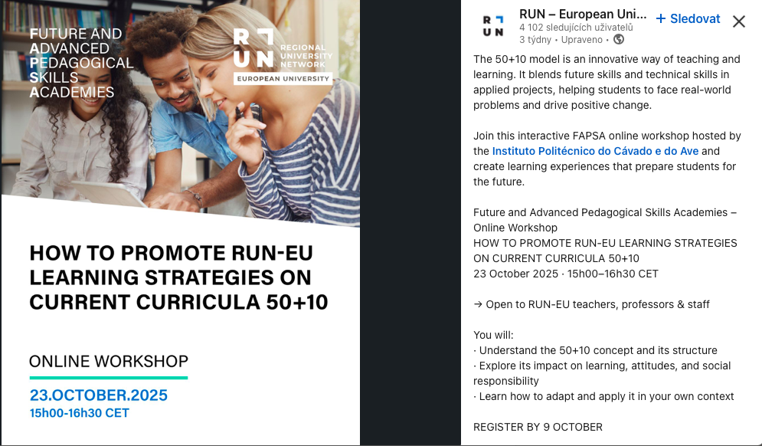

**LINK:** <https://run-eu.eu/2025/09/04/online-workshop-how-to-promote-run-eu-learning-strategies-on-current-curricula-5010/>

The 50+10 model is an innovative way of teaching and learning. It blends future skills and technical skills in applied projects, helping students to face real-world problems and drive positive change.

Join this interactive FAPSA online workshop hosted by the [Instituto Politécnico do Cávado e do Ave](https://www.linkedin.com/company/politecnico-do-cavado-e-do-ave/) and create learning experiences that prepare students for the future.

Future and Advanced Pedagogical Skills Academies – Online Workshop

HOW TO PROMOTE RUN-EU LEARNING STRATEGIES ON CURRENT CURRICULA 50+10

23 October 2025 · 15h00–16h30 CET

→ Open to RUN-EU teachers, professors & staff

You will:

· Understand the 50+10 concept and its structure

· Explore its impact on learning, attitudes, and social responsibility

· Learn how to adapt and apply it in your own context

REGISTER BY 9 OCTOBER

+INFO:<https://lnkd.in/dMx6emiJ>

—

[Technological University of the Shannon](https://www.linkedin.com/company/tus-ie/)

[Polytechnic of Leiria](https://www.linkedin.com/company/politecnicodeleiria/)

[Instituto Politécnico do Cávado e do Ave](https://www.linkedin.com/company/politecnico-do-cavado-e-do-ave/)

[Häme University of Applied Sciences, HAMK](https://www.linkedin.com/company/hamk/)

[NHL Stenden](https://www.linkedin.com/company/nhlstenden/)

[FHV - Vorarlberg University of Applied Sciences](https://www.linkedin.com/company/fachhochschule-vorarlberg/)

[Universidad de Burgos](https://www.linkedin.com/company/universidad-de-burgos/)

[HOWEST University of Applied Sciences](https://www.linkedin.com/company/hogeschool-west-vlaanderen/)